**MICROPROCESSORS AND MICROCONTROLLERS**

**ARDUINO PROJECT REPORT**

Ashish Kumar (2019UCO1518)

Sandeep Jain (2019UCO1522)

Mayank Goel (2019UCO1558)

Gaurav Singhal (2019UCO1571)

Suraj Kumar (2019UCO1559)

Please check out Gdrive ([link](https://drive.google.com/file/d/1CLU2Dv1OqgSxz9hf8o34FG-miWdZaEpo/view?usp=sharing)) for live demo

Please check out Tinkercad ([link](https://www.tinkercad.com/things/c5qt1CwyIoA)) for online simulation and Grive([link](https://drive.google.com/file/d/142EQS4xu3rDvMHQ3KwjbZVtvGprCWU-K/view?usp=drivesdk)) for demostration

Please check out Github ([link](https://github.com/ashish-3916/Arduino-project)) for complete project

# Project Description - Measuring CO2 Concentration in AIR

# Objective

The main motivation and purpose of the device is to tell us real time reading of ppm in environment thereby one can take necessary steps to prevent any hazardous effect on his health considering India is one of the most polluted countries.

Using the device, one will be able to see the real time ppm reading in environment , also one can plot a graph which gives us more accurate idea about our environment. Thiw will also create awareness among people towards their ecosystem.

## **Idea and Concept**

The Humans are always fast-paced, rapidly changing, and evolving.

Their negligence towards their environment and ecosystem has changed the dynamics of nature. Ozone layer is depleting, the earths atmospheric co2 level is increasing day by day, we all are living in a gas chamber made by us containing harmful gases.

Due to this reason the need of the time is to take immediate and necessary steps to deal with situation. One can be critical of environment, if he knows the hazardous consequences of its deprivation.

Therefore we aim to create a economical feasible device which gives us a nearabout idea of our surroundings.

**PROBLEM STATEMENT**: NEGLIGENE TOWARDS SOCIETY HAS MADE DELHI AND INDIA ONE OF MOST POLLUTED PLACES. NEED OF AWARENESS IS MORE THAN EVER BEFORE.

**HOW TO SOLVE THE PROBLEM: -** AN ECONOMIC AND FEASIBLE PRODUCT WHICH MAKES US REALIZE THE CONDITION OF AIR WE BREATH SO THAT WE BECOME MORE CAREFUL TOWARDS OUR ECOSYSTEM

**ABOUT PROJECT:**

* + Our proposal is a CO2 device that logs the data from the CO2 sensor onto an OLED Display Module for further analysis.
  + We are going to use an MQ-135 sensor with Arduino to measure the CO2 concentration.
  + The measured CO2 concentration values will be displayed on the OLED module
  + We will also compare the Arduino MQ-135 sensor readings with Infrared CO2 sensor readings.

**COMPONENTS REQUIRED:**

* + Arduino Nano
  + MQ-135 Sensor
  + Jumper Wires
  + 0.96 inch I2C/IIC 128x64 OLED Display Module 4 Pin
  + Breadboard
  + 22KΩ Resistor

**SIMULATORS USED:**

* + ArduinoDroid App
  + Tinkercad playground

**Arduino Nano:**

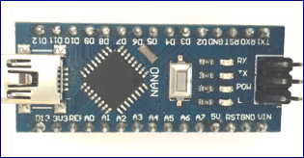

**Arduino Nano Pin Configuration:**

|  |  |  |
| --- | --- | --- |
| Pin Category | Pin Name | Details |
| Power | Vin , 3.3V,5V,GND | **Vin:** Input voltage to Arduino when using an external power source (6-12V).  **5V:** Regulated power supply used to power microcontroller and other components on the board.  **3.3V:** 3.3V supply generated by on-board voltage regulator. Maximum current draw is 50mA.  **GND:** Ground pins. |
| Reset | Reset | Resets the microcontroller |
| Analog Pins | A0 - A7 | Used to meansure analog voltage iin the range of 0-5V |
| Input / output pins | Digital pins D0 – D13 | Can be used as input or output pins . 0V (low) and 5V (high) |
| Serial | Rx,Tx | Used to receive and transmit TTL serial data |
| External interrupt | 2,3 | To trigger an inteerupt |
| PWM (pulse width modulation) | 3,5,6,9,11 | Provide 8 bit PWM output |
| Inbuild LED | 13 | To turn on the inbuild LED |

### ****Arduino Nano Technical Specifications:****

|  |  |
| --- | --- |
| Operating voltage | 5V |
| Input voltage for Vin pin | 7 – 12 V |
| Analog input pins | 6 (A0 – A5) |
| Digital i/o pins | 14 |
| Frequency (clock speed) | 16MHz |
| SRAM | 2Kb |

**MQ-135 Sensor:**

There are various gas sensors present in the market . Few of them are:

|  |  |
| --- | --- |
| Sensor Name | Gas to measure |
| [MQ-2](https://components101.com/mq2-gas-sensor) | Methane, Butane, LPG, Smoke |
| MQ-3 | Alcohol, Ethanol, Smoke |
| MQ-4 | Methane, CNG Gas |
| MQ-5 | Natural gas, LPG |
| MQ-6 | LPG, butane |
| MQ-7 | Carbon Monoxide |
| MQ-8 | Hydrogen Gas |
| MQ-9 | Carbon Monoxide, flammable gasses |
| MQ131 | Ozone |
| MQ135 | Air Quality |
| MQ136 | Hydrogen Sulphide gas |
| MQ137 | Ammonia |
| MQ138 | Benzene, Toluene, Alcohol, Propane, Formaldehyde gas, Hydrogen |
| MQ214 | Methane, Natural Gas |
| MQ216 | Natural gas, Coal Gas |
| MQ303A | Alcohol, Ethanol, smoke |
| MQ306A | LPG, butane |
| MQ307A | Carbon Monoxide |
| MQ309A | Carbon Monoxide, flammable gas |

We will be using MQ – 135 for CO2 detection

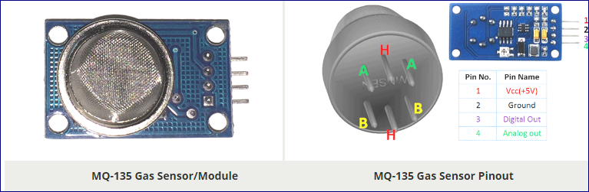

**Pin configuration :**

|  |  |  |
| --- | --- | --- |
| Pin No: | Pin Name: | Description |
| For Module | | |
| 1 | Vcc | Used to power the sensor, Generally the operating voltage is +5V. |
| 2 | Ground | Used to connect the module to system ground. |
| 3 | Digital Out | You can also use this sensor to get digital output from this pin, by setting a threshold value using the potentiometer. |
| 4 | Analog Out | This pin outputs 0-5V analog voltage based on the intensity of the gas. |
| For Sensor | | |
| 1 | H -Pins | Out of the two H pins, one pin is connected to supply and the other to ground |
| 2 | A-Pins | The A pins and B pins are interchangeable. These pins will be tied to the Supply voltage. |
| 3 | B-Pins | A pins and B pins are interchangeable. One pin will act as output while the other will be pulled to ground. |

**MQ-135 Sensor Features**

* Wide detecting scope
* Fast response and High sensitivity
* Stable and long life
* Operating Voltage is +5V
* Detect/Measure NH3, NOx, alcohol, Benzene, smoke, CO2, etc.
* Analog output voltage: 0V to 5V
* Digital output voltage: 0V or 5V (TTL Logic)
* Preheat duration 20 seconds
* Can be used as a Digital or analog sensor
* The Sensitivity of Digital pin can be varied using the potentiometer

**0.96 inch I2C/IIC 128x64 OLED Display Module 4 Pin**

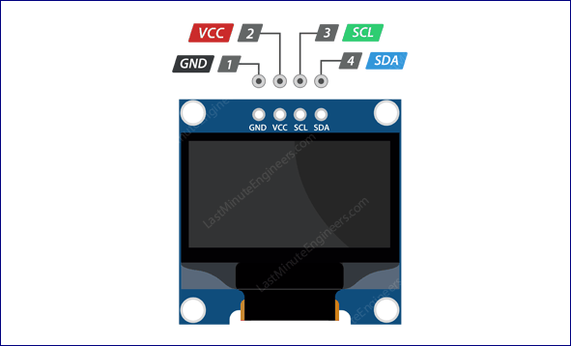

GND should be connected to the ground of Arduino

VCC is the power supply for the display which we connect the 5 volts pin on the Arduino.

SCL is a serial clock pin for I2C interface.

SDA is a serial data pin for I2C interface.

**Connections:**

* VCC pin to the 5V output on the Arduino
* GND to ground
* SCL is connected to pin A5 of arduino nano
* SDA is connected to pin A4 of arduino nano

**TINERCAD PLAYGROUND :**

Visit [TINKERCAD](https://www.tinkercad.com/things/c5qt1CwyIoA)to check live stimulation on tinkercad playground.

Also visit [VIDEO](https://drive.google.com/file/d/142EQS4xu3rDvMHQ3KwjbZVtvGprCWU-K/view?usp=drivesdk) for explanation on working for the same .

We have used default components which are present in tinkercad playground.( eg arduino uno)

**Snapshots:**

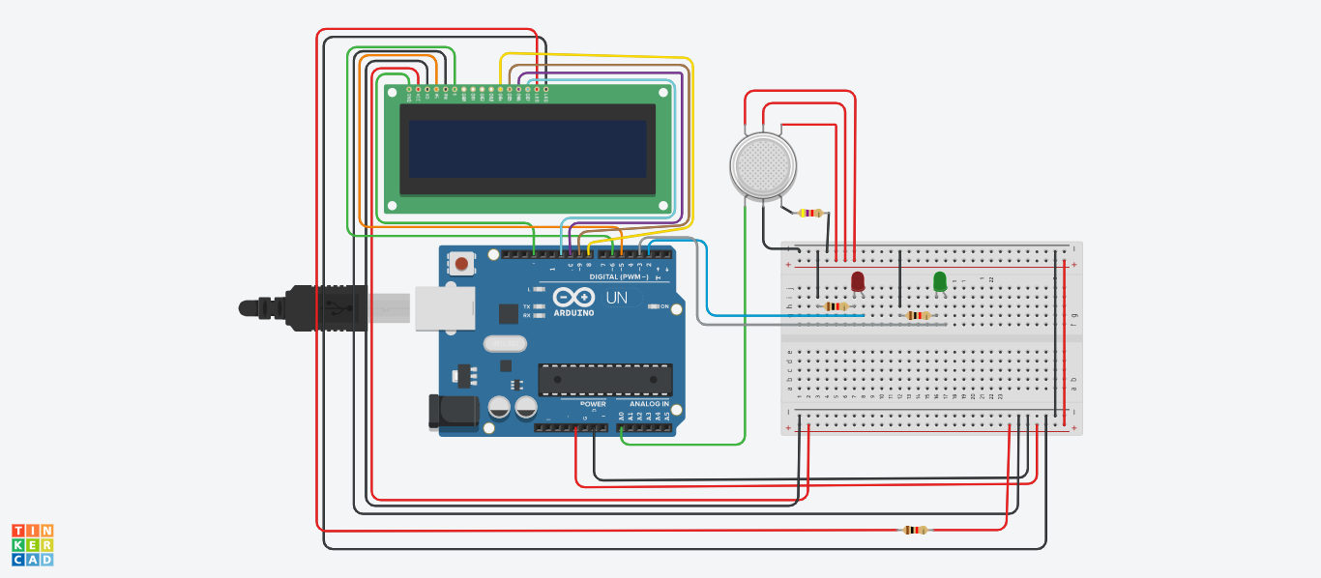

A smoke is used as demonstration to CO2 concentration .

When concentration is high near the sensor, display shows “HIGH PPM CONCENTRATION” and RED LED is turned ON .

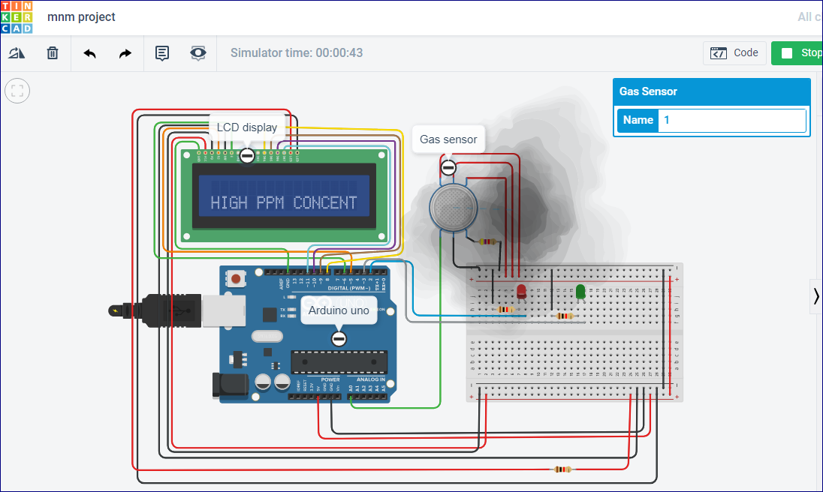

When concentration is low near the sensor, display shows “MODERATE PPM CONCENTRATION” and GREEN LED is turned ON .

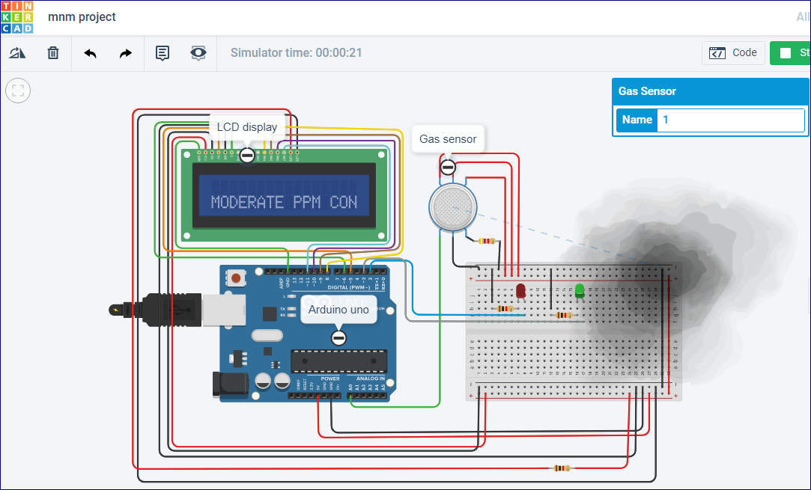

**IMPLEMENTING THE PROJECT :**

CODE:

//project for co2 detection

//header file

// for graphic primitives

//for Arduino sketch

#include <Adafruit_SSD1306.h>

#include <Adafruit_GFX.h>

#include <SPI.h>

//Serial Peripheral Interface (SPI)

#include <MQ135.h>

// for communication

#include <Wire.h>

Adafruit_SSD1306 display(-1);

MQ135 gasSensor = MQ135(A0);

int Pin = A0;

// setup loop initiaing sensor pin

//we started at 9600

//initiating display

void setup() {

gasSensor = MQ135(Pin);

Serial.begin(9600);

pinMode(Pin, INPUT);

display.begin(SSD1306_SWITCHCAPVCC, 0x3C);

display.clearDisplay();

}

//working repeatedly

//printing ppm value on screen

// expexted value to change when we creae disturbance

// setting text_size and text_color

void loop() {

display.setTextSize(3);

float rzero = gasSensor.getRZero();

float ppm = gasSensor.getPPM();

Serial.print ("ppm: ");

Serial.println (ppm);

display.setTextSize(1.2);

display.setTextColor(WHITE);

display.setCursor(0,28);

display.print("ppm ");

display.println(ppm);

display.display();

delay(200);

display.clearDisplay();

}

SNAPSHOTS:

**SERIAL OUTPUT OF PPM CONCENTRATION :**

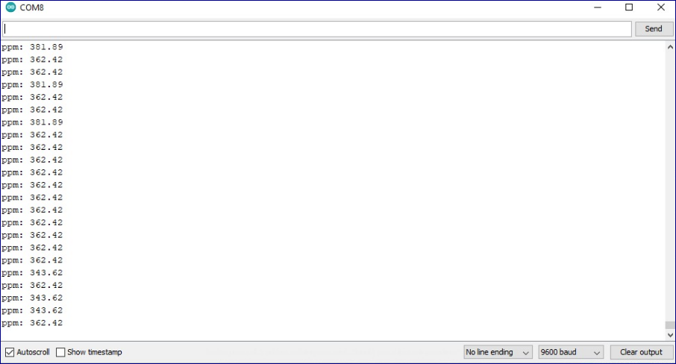

**GRAPHICAL REPRESENTION / ANALYSIS OF PPM CONCENTRATION**

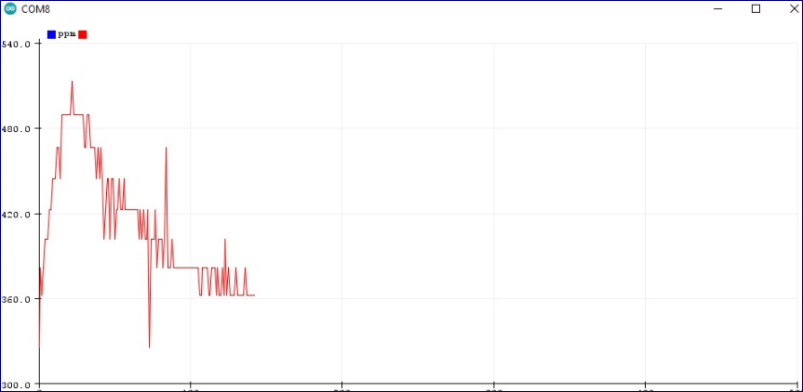

**SETUP IN WORKING CONDITION :**

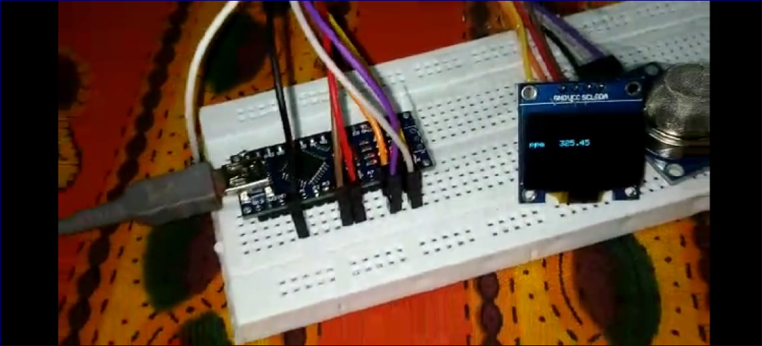

**LIMITATIONS:**

* + The sensor (like commercial ones) undergoes some delay in measuring the concentration of CO2.
  + The measurement range is 0–1000 ppm. Concentrations not included in this range will not be measured
  + Extreme relative humidity, temperature, and voltage can affect the measurements

**Checkout Github (**[**link**](https://github.com/ashish-3916/Arduino-project) **) for the complete project .**